Lab 5: Learning the Feature of IIS in Azure Virtual Machine using Windows Server

Theory
Internet Information Services (IIS) is a web server developed by Microsoft for hosting websites, web applications, and services on Windows Server. When deployed inside an Azure Virtual Machine running Windows Server, IIS allows users to host web content in a cloud-based environment with high availability, flexibility, and scalability.
Key concepts:

1. Azure VM (Windows Server)
- A virtual machine created in Azure with a Windows Server operating system.
- Acts as a cloud-based computer where IIS can be installed and configured.
- Provides remote access via RDP (Remote Desktop Protocol).

2. IIS (Internet Information Services)
- A built-in Windows feature.
- Supports HTTP, HTTPS, FTP, and application hosting.
- Installs through:
  - Server Manager → Add Roles and Features
  - Enabling the Web Server (IIS) role.

3. Default Web Page
- After IIS installation, accessing the VM’s public IP address displays the IIS default landing page, confirming that the server is running.

4. Hosting Custom Content
- Users can modify files inside: C:\inetpub\wwwroot
- Replacing index.html or adding a new file modifies what is displayed in the browser.
- This demonstrates how websites are hosted on IIS.
In Azure, IIS hosting benefits from the cloud’s scalable resources, public IP accessibility, and network security controls.

Steps:
- Setup a Windows Server Virtual Machine in Azure:
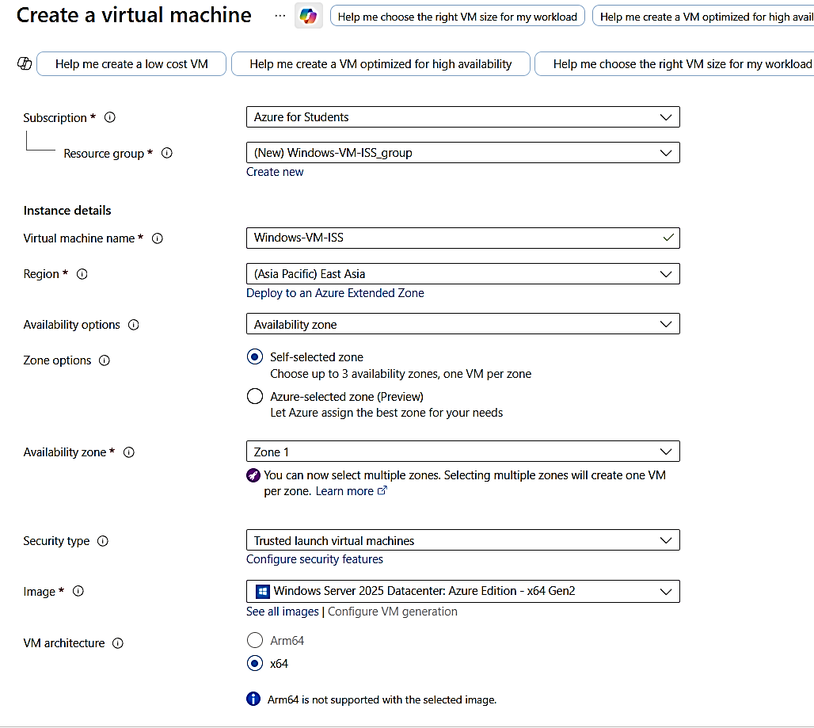
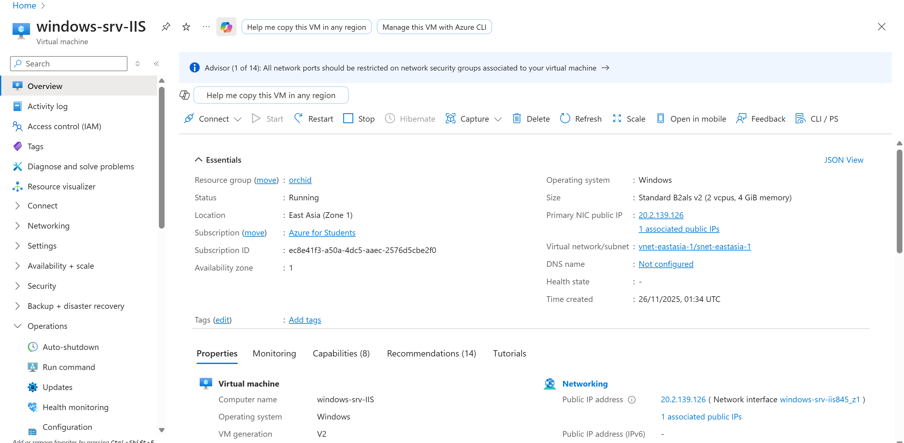
- Establish a Remote Desktop Connection to your Azure Virtual Machine and download the RDP file:

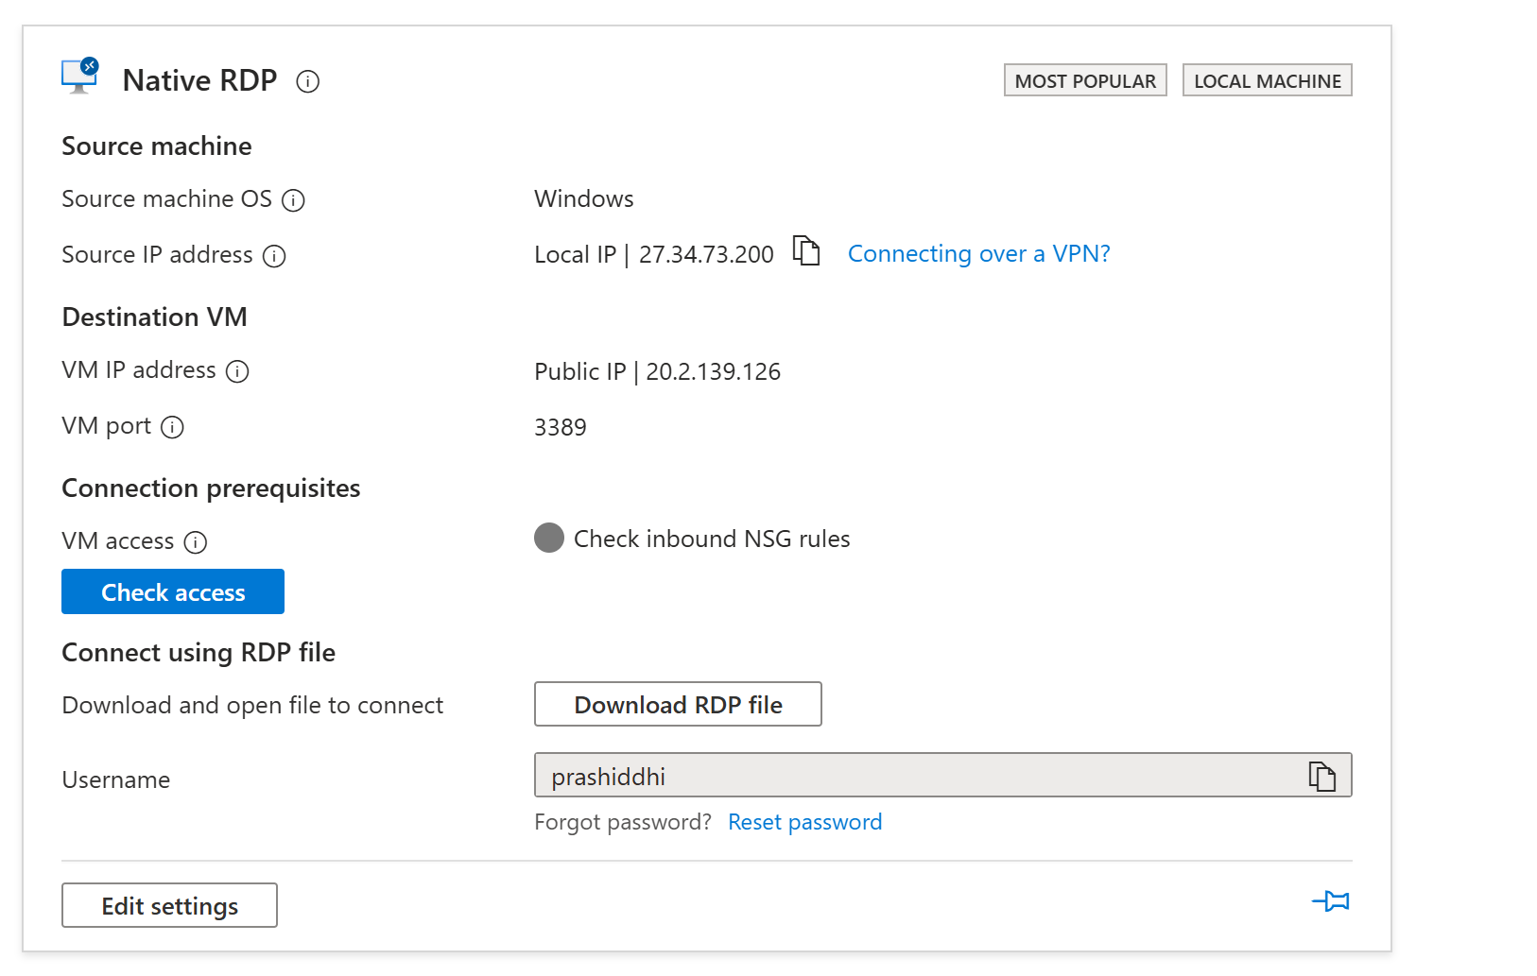

- Enter the required information in Remote Desktop Connection to access the Azure Windows Server:

  - Enter your VM’s public IP:

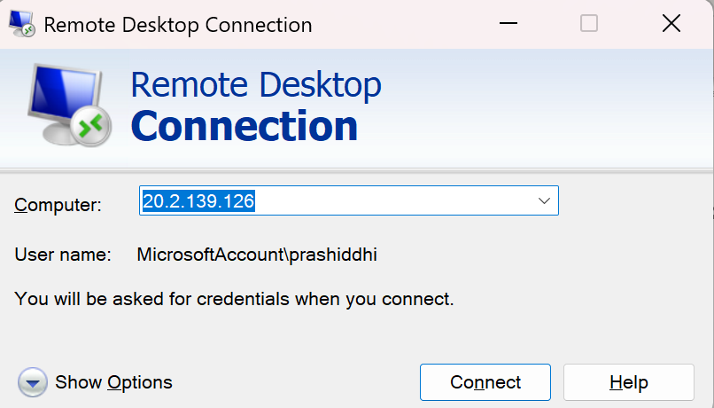

  - Enter the credentials you entered while creating the VM:

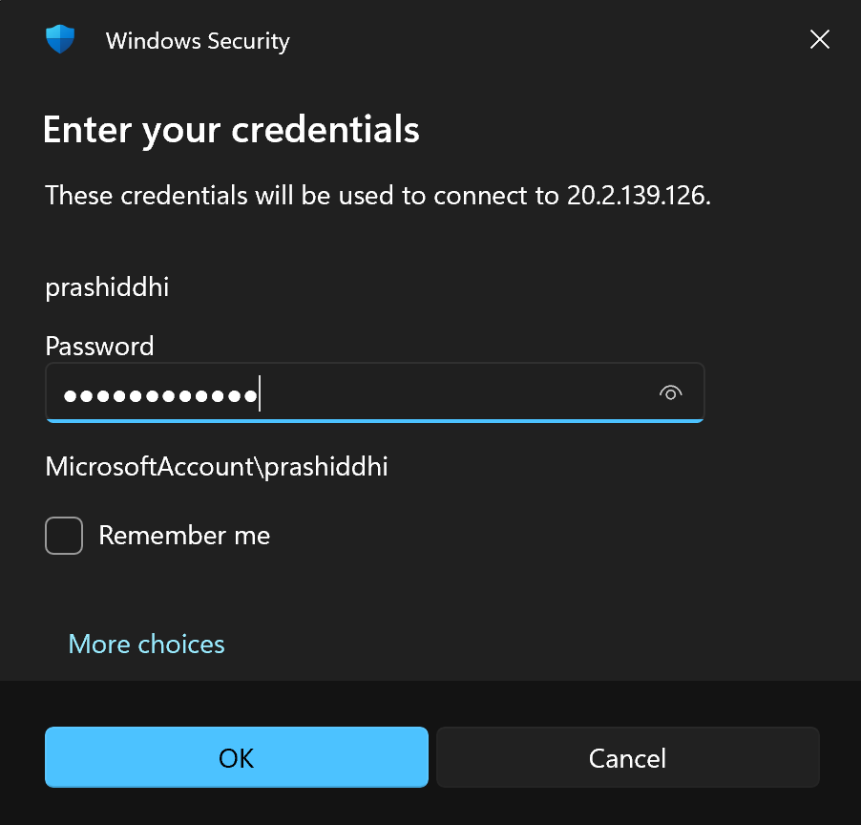

  - After authentication, connection is succesful after clicking Yes:

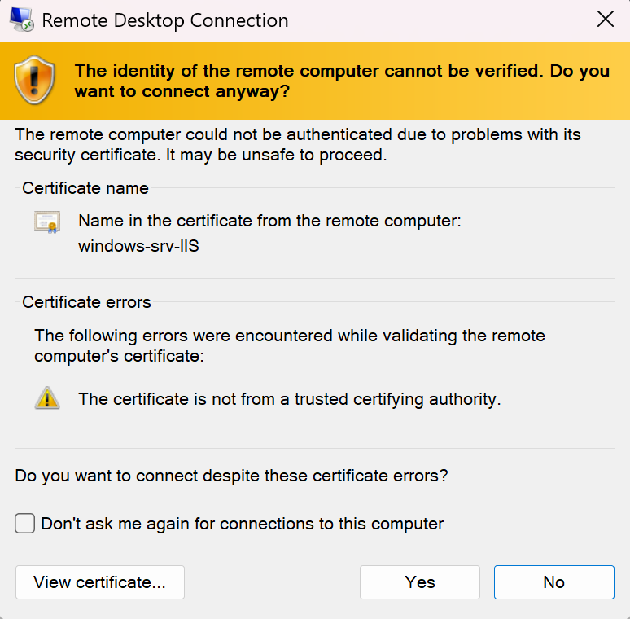

- Once you gain access to the Azure windows server,

    - Install Web Server (IIS):

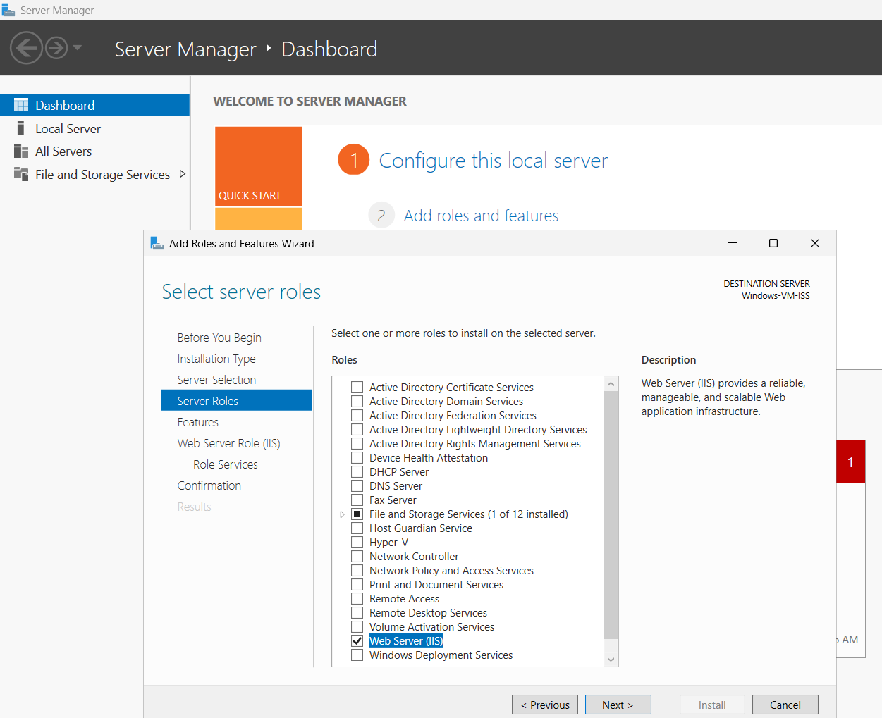

    - Go inside C:\inetpub\wwwroot and modify the file called ‘iisstart.htm’:


- Now access the modified webpage via the virtual machine’s public IP in your local device:



Result and Conclusion:

Result: In this lab, a Windows Server Virtual Machine was successfully created and accessed using RDP. IIS was installed through the Server Manager interface by enabling the Web Server (IIS) role. After installation, browsing the VM’s public IP displayed the default IIS page. A custom HTML file was then added or edited inside the directory C:\inetpub\wwwroot. When the page was refreshed through a browser using the VM's public IP, the custom content appeared, confirming that IIS was correctly serving user-modified webpages. The experiment verified the functionality of IIS on Azure and demonstrated how web content can be hosted and modified in a cloud-hosted Windows Server environment.
Conclusion: The lab exercise showed that Azure Virtual Machines can effectively host web services using IIS on Windows Server. Installing IIS through Server Manager is straightforward, and the Azure environment makes the hosted website accessible globally via the VM’s public IP address. By modifying the default webpage, the lab confirmed the ability to deploy and customize web content. This practical experience highlights the usefulness of IIS for cloud-based hosting and demonstrates Azure’s capability to run Windows-based web infrastructure.

